Name: Sergio Gutierrez

bitbucket Repo: <https://bitbucket.org/SergioZGutierrez/homework/src/master/>

Homework2

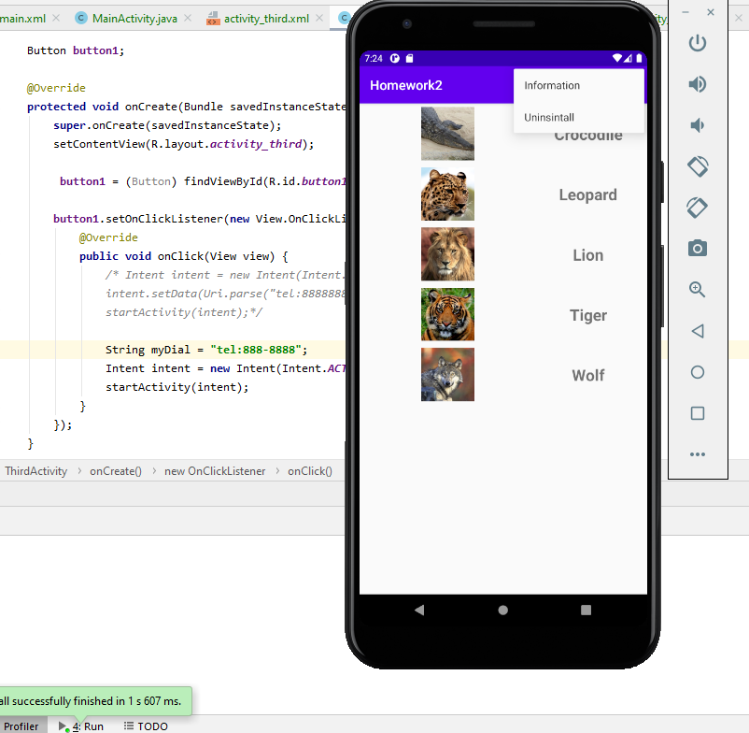

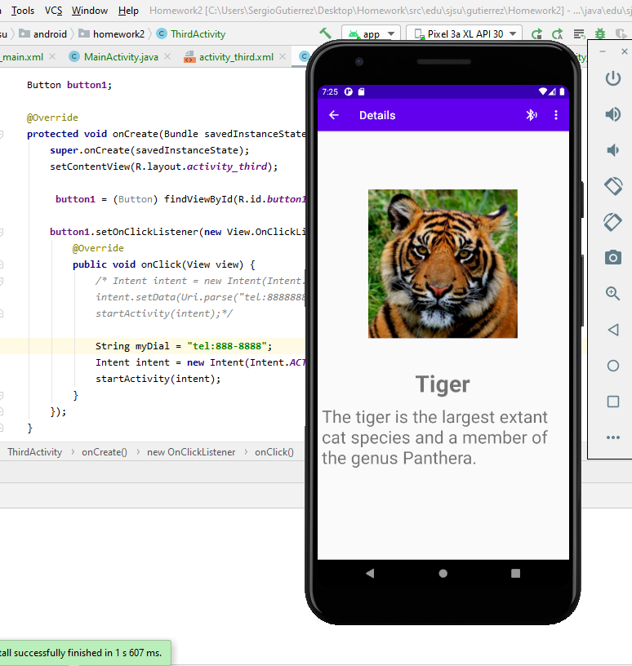

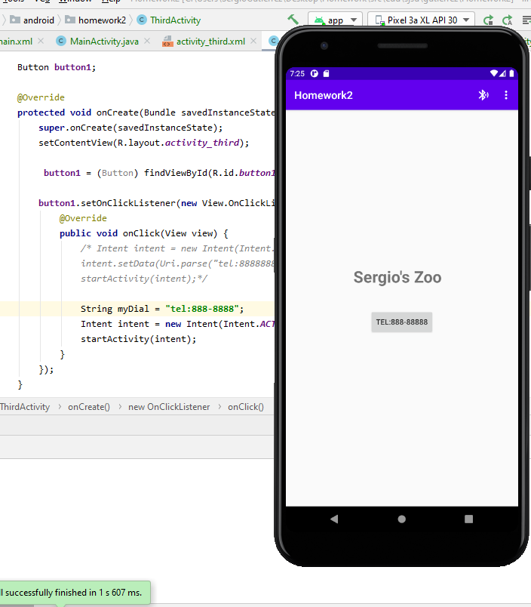

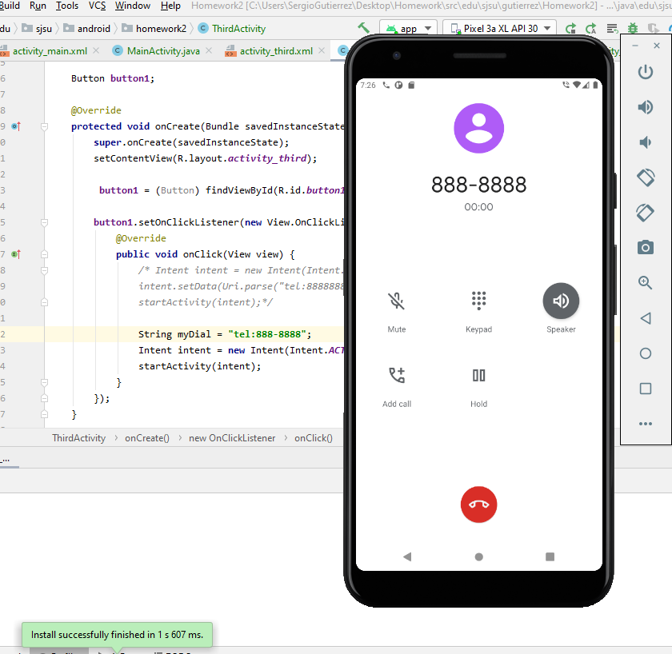

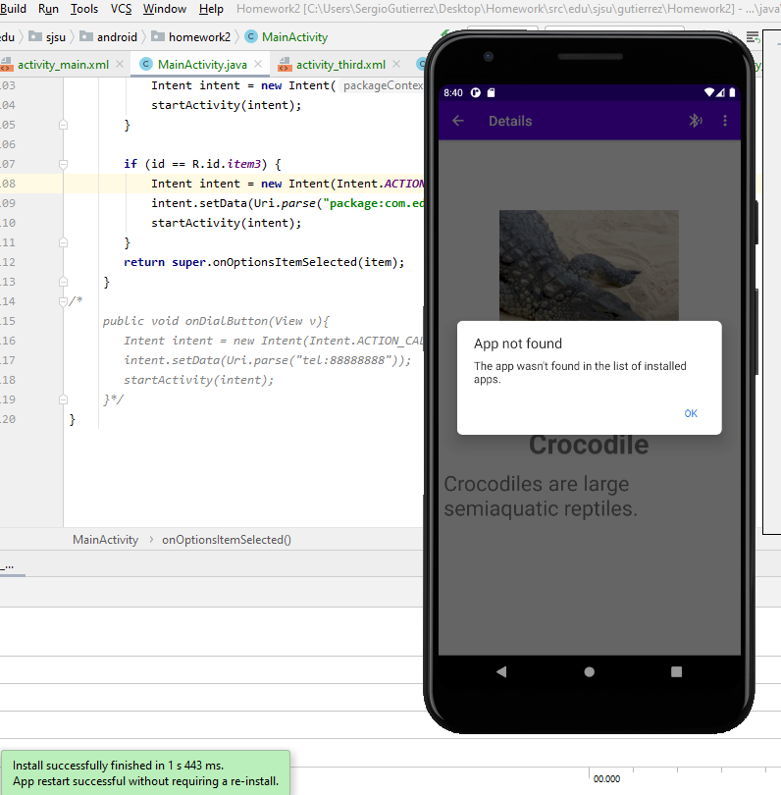

Please note that when attempting to uninstall the app, if you already have it in your directory, it’ll say ask you if you want to uninstall it. Otherwise, it will display the above.

The exact pathway of where the .java files are located in my repository are:

<https://bitbucket.org/SergioZGutierrez/homework/src/master/SimpleAdapter/app/src/main/java/edu/sjsu/android/Homework2/>

Or, you can simply look up this folder:

